Learning Guide:

United States of America Capitol Building

Overview:

The Capitol Building within the United States of America holds both chambers of the legislative branch—the House of Representatives and the Senate. This model illustrates the architecture of the building and where each part of the legislature is located.

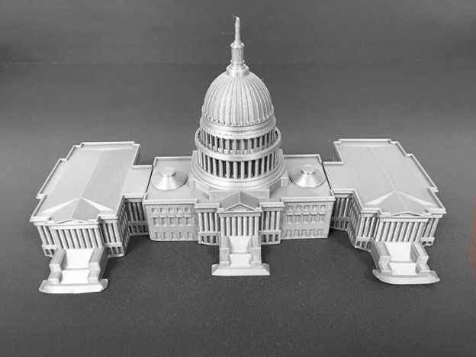
Model designed by MakerBot from https://www.thingiverse.com/thing:461272
The image above depicts the 3D model for the United States of America Capitol Building

Walkthrough:

- Place the flat side of the model on a surface so the tall point in the middle of the model is directed upwards. When putting the model together, the front of the model has rectangular stairs while the back side of the model is flat.

- Feel for the highest point of the model for a narrow cylinder. This is a statue that symbolizes freedom. Below the highest point of the model is a dome with vertical lines moving down. This dome is 288 feet (88 meters) high and the diameter is 96 feet (29 meters).

- Below the dome, you will feel a large rectangular prism that is wide but not very long. Inside this rectangular prism is the area dedicated mostly to offices and galleries with statues and artifacts for visitors. Examine the details on this rectangular prism. The rectangles on the front of the prism are windows, and there are 658 total windows on the Capitol Building. You will also feel rows of long cylinders, which are pillars in front of the building. Throughout Washington D.C., many government buildings and memorials have these rows of pillars.

- Move your hand to the right until you feel another rectangular prism. This should feel like another building that is attached to the main body of the Capitol building. This part of the building holds the chamber for the House of Representatives. In the House, there are 435 representatives that vote and legislate important bills. Like the middle of the building you will feel similar details such as pillars.

- Move your hand all the way to the left of the model. You will feel a rectangular prism that feels identical to the House of Representatives chamber. This chamber belongs to the Senate. Within the Senate, there are 100 members that vote and legislate bills like the House.

- The Capitol building covers about 4 acres of land and is about 751 feet (229 meters) long.

Citations:

“U.S. Capitol Building.” Architect of the Capitol, 2020, www.aoc.gov/explore-capitol-campus/buildings-grounds/capitol-building.
“U.S. Capitol Map.” U.S. Capitol Visitor Center, 2020, www.visitthecapitol.gov/plan-visit/us-capitol-map.

